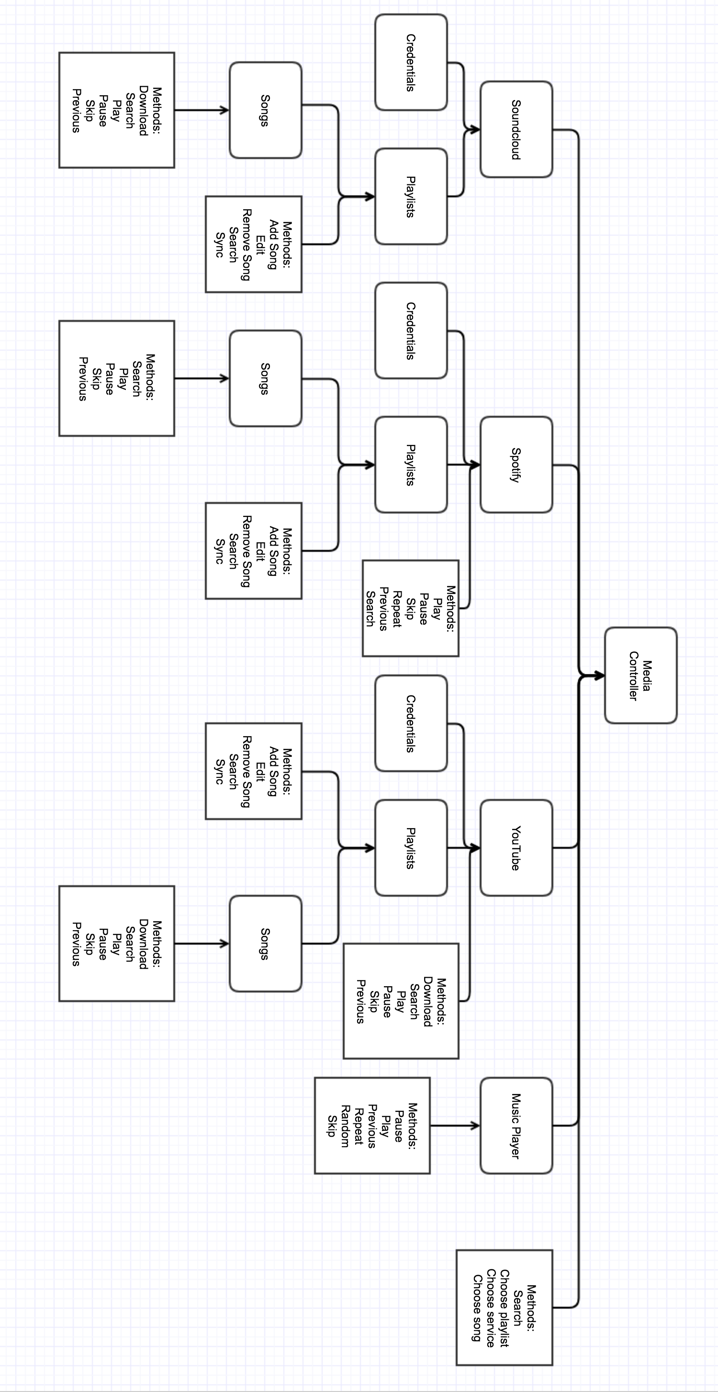

|  |  |
| --- | --- |
| NOUNS | VERBS |
| Media Controller Soundcloud  Spotify  Playlists  Songs  YouTube | Add Change volume  Download  Play  Pause  Previous  Repeat  Remove  Search  Skip  Sync |

Required Data

Credentials

* Soundcloud
* Spotify
* YouTube

Playlists

* Soundcloud
* Spotify
* YouTube

|  |  |
| --- | --- |
| * Media Controller | Search  Choose playlist  Choose service  Choose song |
| Music Player | Pause  Play  Previous  Repeat  Random  Skip |
| Playlists | Add Song  Edit  Remove Song  Search  Sync |
| Song | Play  Pause  Skip  Repeat  Previous  Search |

|  |  |
| --- | --- |
| Soundcloud | Download  Search  Play  Pause  Skip  Previous |
| Spotify | Search  Play  Pause  Skip  Previous |
| YouTube | Download  Search  Play  Pause  Skip  Previous |